**REPORT**

The assignment consists of two parts. Each of sections involve the use of two depth and color frames using Microsoft Kinect. Using pixel values and in-built OpenCV functions we solve each section.

We have the following provided:

* Color and depth frames - an initial and a final frames of the sequence - obtained from Kinect, along with time instants of capture.
* Camera intrinsic matrix for RGB camera,
* Inverse of camera intrinsic matrix of the depth camera and rotation matrix between RGB and depth camera.

Color Images:

**Frame 1**  
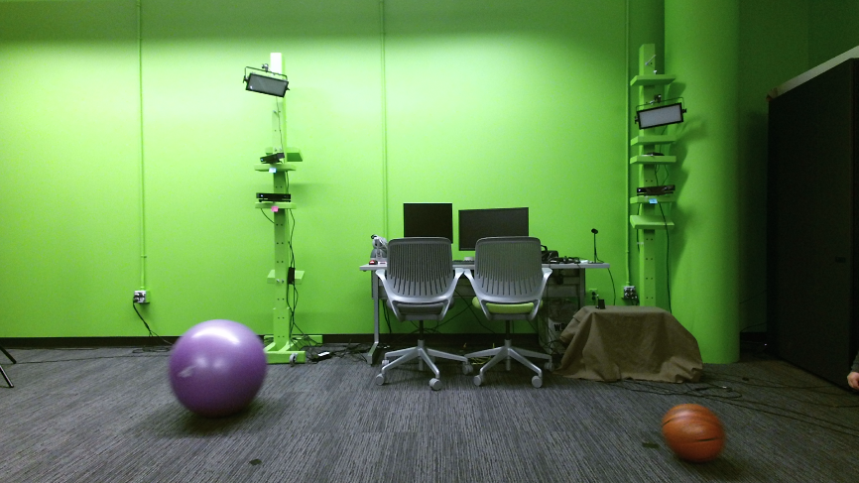

**Frame 2**  
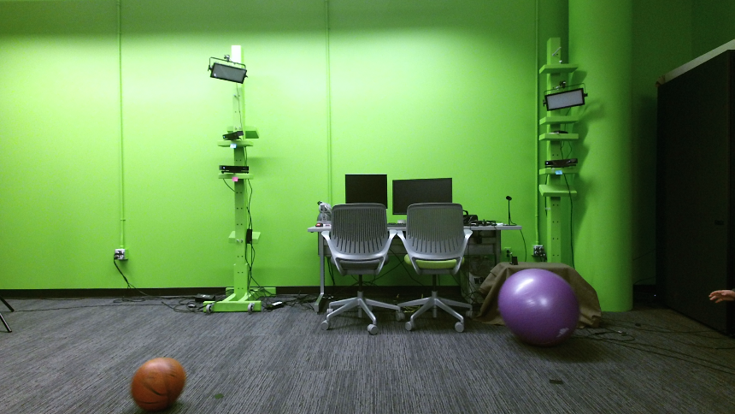

Depth Images:

**Frame 1**  
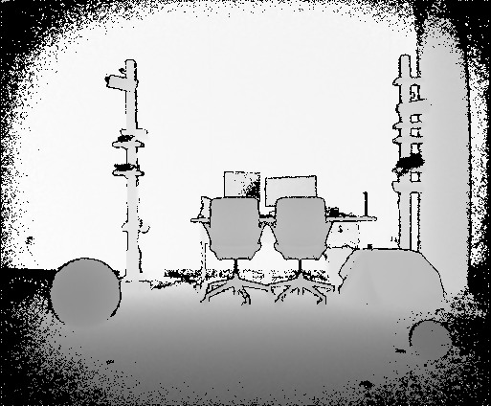

**Frame 2**  
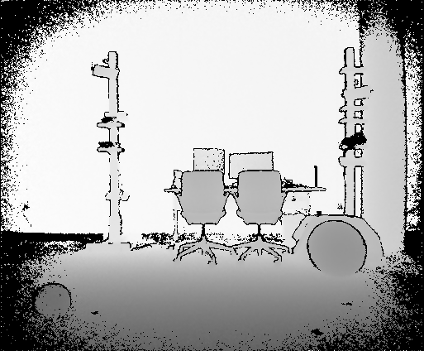

Each section of the assignment is explained as follows:

1. **Find the corresponding color of each pixel in the depth image to obtain a colorized depth image. Further draw a bounding box around each ball.**In order to generate a colorized depth image, for each pixel in the depth image, we need to find the corresponding pixel in the color image.   
   Consider the following:  
   (uD,vD) = Pixel in the depth image   
   (XD,YD,ZD) = 3D point in depth camera’s coordinate system.  
   (uC,vC) = Pixel in the color image   
   (XC,YC,ZC) = 3D point in color camera’s coordinate system.  
   We first project each 2D point of the depth image (uD,vD) onto 3D (XD,YD,ZD) using the following equation  
    ZD=Depth value at ();   
    [XD/ZD YD/ZD 1]=[uD vD 1] * [Inverse Intrinsic Matrix]  
   Next we calculate the corresponding 3D pixel in the color image as follows  
    [XC YC ZC 1] = [XD YD ZD 1] * [Transformation matrix]  
     
   Further, we project each 3D point in the color image (XC,YC,ZC) to its corresponding 2D point (uC,vC) as follows  
   [uC vC 1] = [XC/ZC YC/ZC 1] * [Intrinsic Matrix]  
     
   We then replace the RGB values in the depth image for each pixel (x,y) with the RGB values of the corresponding point (uC,vC) in the color image.  
     
   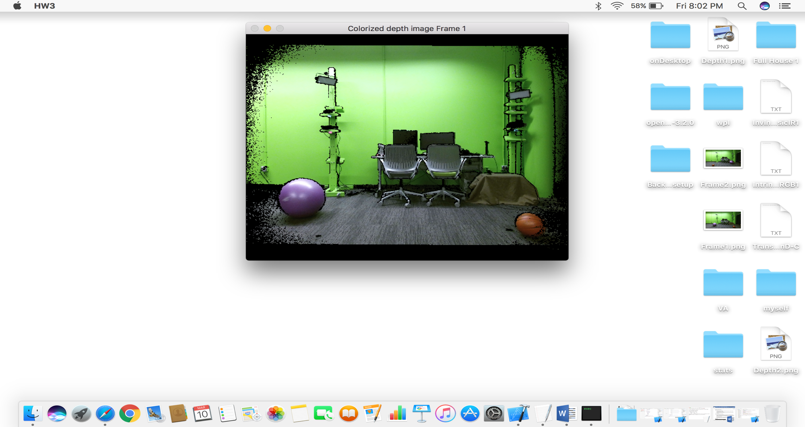

Frame 1 – Colorized depth image

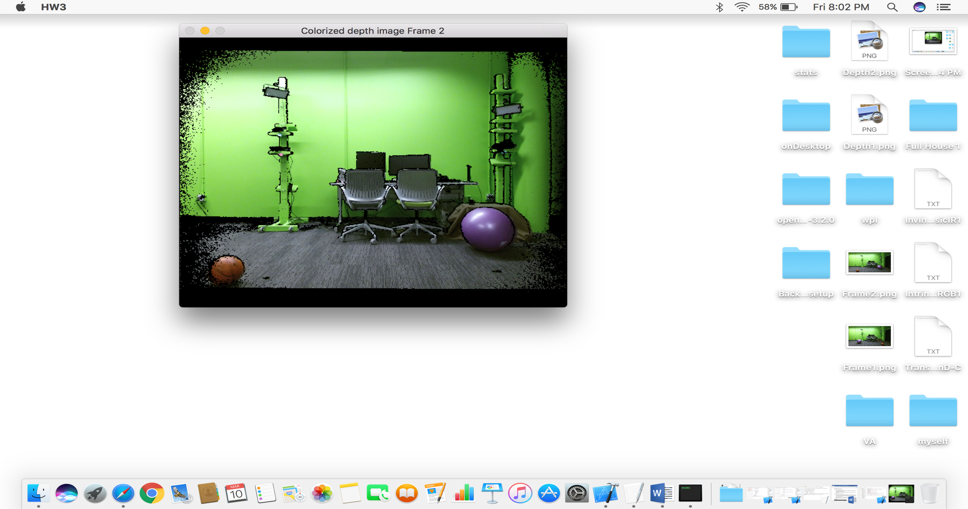

Frame 2 – Colorized depth image  
  
  
Bounding boxes   
In order to draw the bounding boxes, using the threshold values of the color each ball, we find the x_min, x_max, y_min and y_max values. These values are further used to find the center of each ball as well as draw a box around it using OpenCV in-built functions.

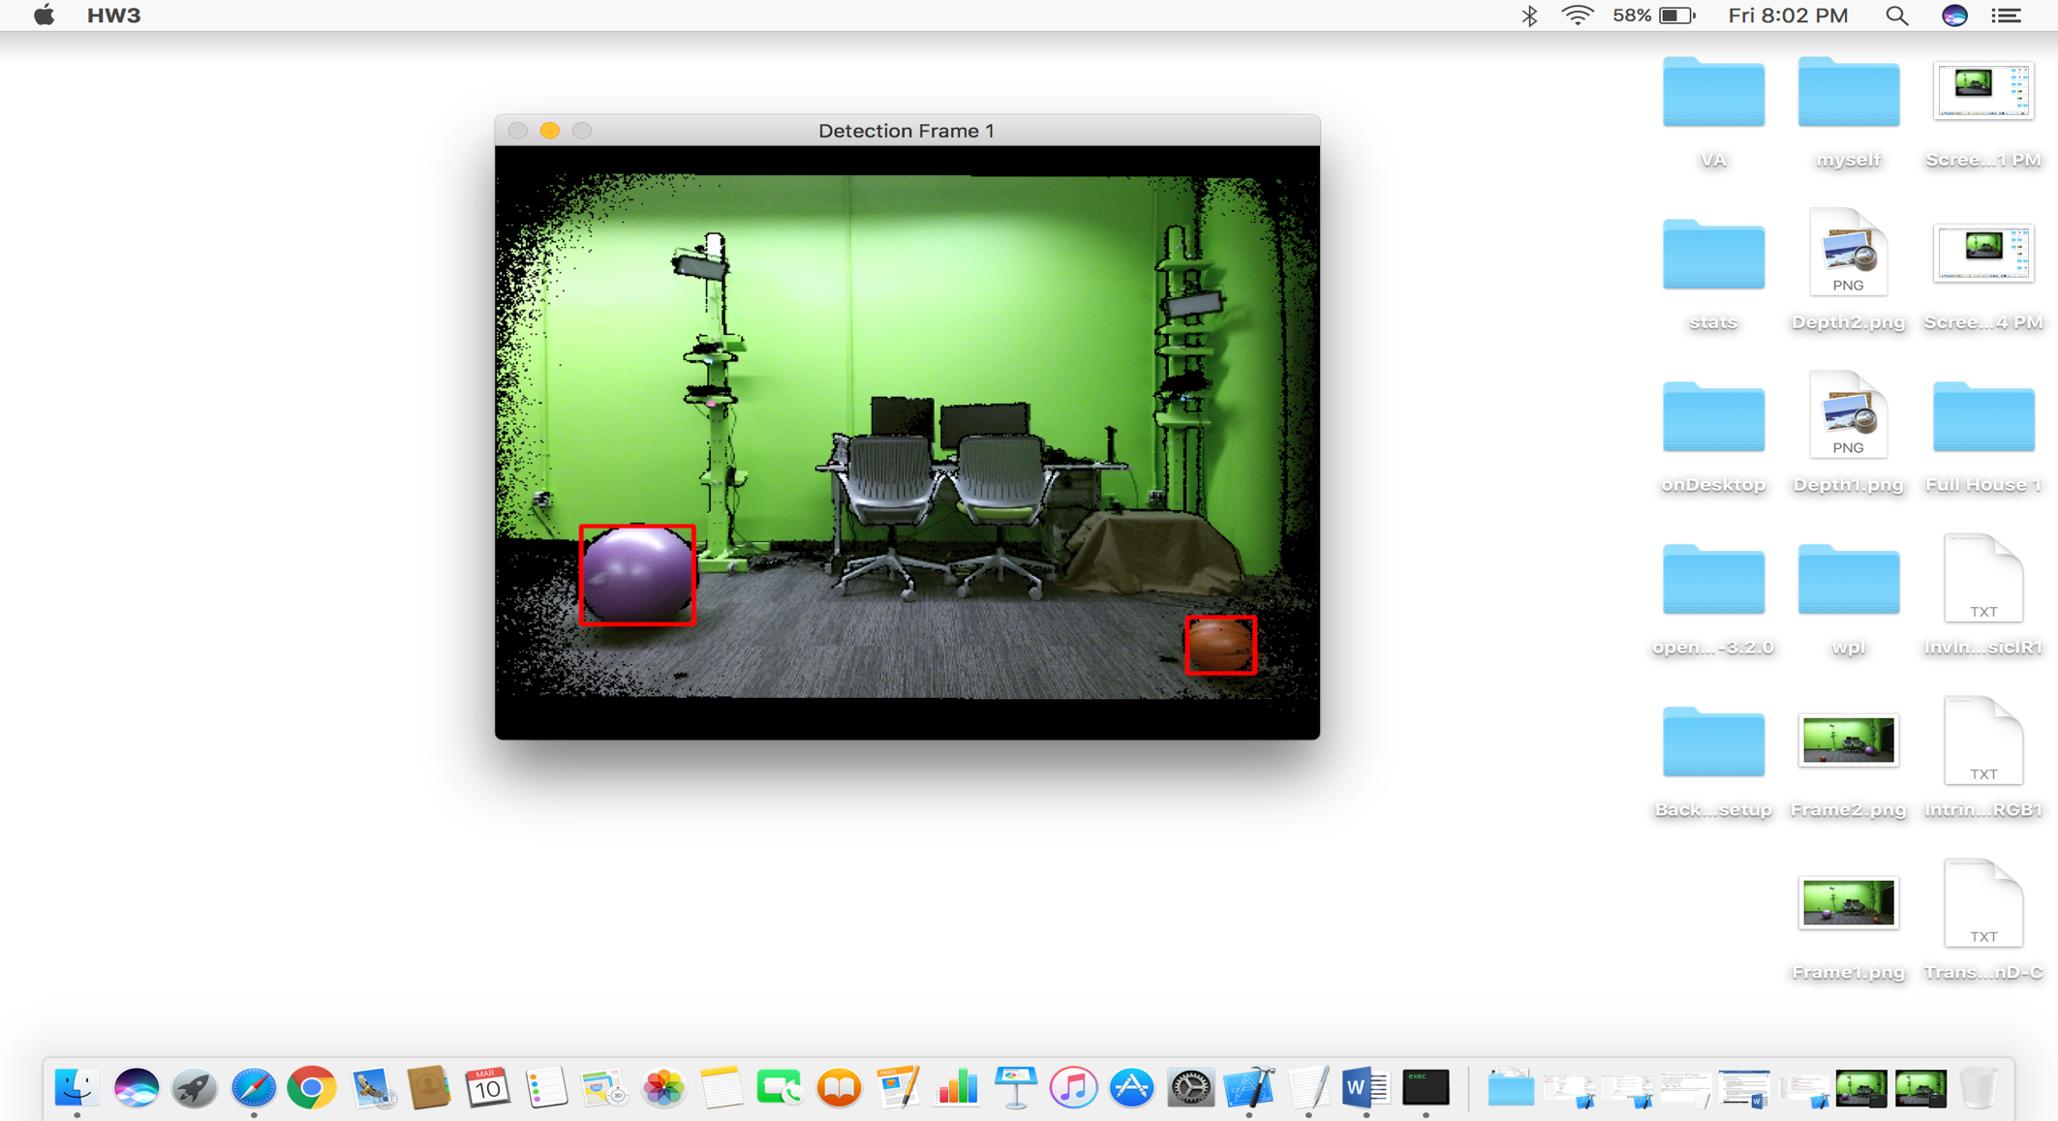

Frame 1- Detection of balls

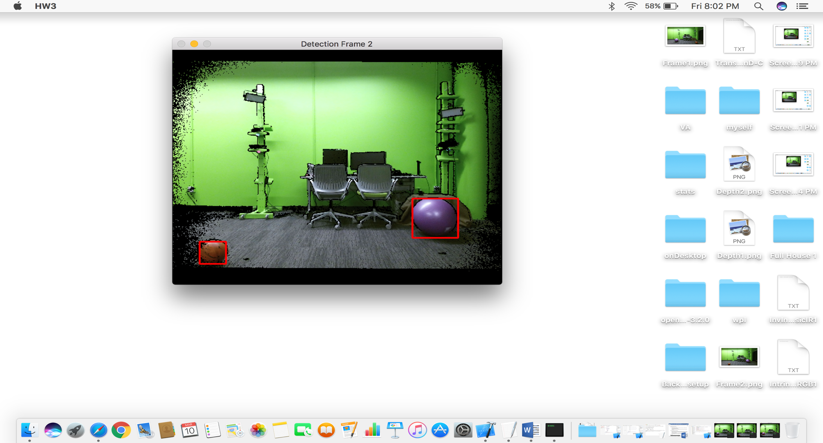

Frame 2- Detection of balls

1. **Using the Initial and Final positions of the balls and calibration values compute the Relative Velocities in millimeters/second.**In each frame, from the previous section, we have the center coordinates of each ball. Thus, for each color ball, we find the distance spanned by the ball by calculating the difference in the coordinate values. The velocity of each ball is further calculated by dividing this distance with the time duration between the two frames (given).  
     
   The Relative velocity of one ball with respect to the other is calculated by subtracting the velocities of each opponent ball that is observed from the ball it is viewed from. The velocities are expressed in a vector form.

The magnitude of the velocities is further calculated by taking the square root of the sum of squares of the individual component.

The angle of the vectors is calculated by taking the Tan-1 of the x and y components and then using this resultant with the z-component to find the final angle.

